Championat 2020 – Stilling
 | Spring | Dressur | Military
Hest | Helle Pedersen / Hannibal – 16 point | Cecilie Sarah Madsen / Stenbjergs Elton – 66 point  Tina Teglers / Memphis – 12 point
Pony | Annika Hartung Holmboe / Højvangs Recollo (1) – 9 point | Annika Hartung Holmboe / Don Domingo E (1) – 63 point  Anton Lykke / Foldbergs Filur (1) – 26 point

Championat 2019 – Stilling
 | Spring | Dressur | Military
Hest | Helle Pedersen / Hannibal – 28 point | Tina Teglers / Memphis – 18 point | Amalie Ravn Petersen / Cascadeur Rouge – 5 point
Pony | Anine Parslov Vogelsang / Fwrog Flash Harri (2) – 8 point | Annika Hartung Holmboe / Don Domingo E (1) – 65 point  Anine Parslov Vogelsang / Fwrog Flash Harri (2) – 49 point  Anton Lykke / Scooby (3) – 10 point | Anine Parslov Vogelsang / Fwrog Flash Harri (2) – 1 point

Championat 2018 – Stilling

Hest – Dressur | Hest – Spring | Hest – Military | Pony – Dressur | Pony – Spring | Pony – Military
Jacqueline Berglund Andersen/ Drumbeat: 23 point | Monica Sørensen/ Backfisch “K”: 4 point  Amalie Ravn Petersen/ Cascadeur Rouge: 4 point | Amalie Ravn Petersen/ Cascadeur Rouge: 6 point | Anine Parslov Vogelsang/ Fwrog Flash Harri: 22 point  Anine Parslov Vogelsang/ Nørlunds Eclipse: 8 point  Annika Hartung Holmboe/ Højvangs Recollo: 5 point  Annika Hartung Holmboe/ Adonis: 5 point | Anine Parslov Vogelsang/ Fwrog Flash Harri: 12 point  Annika Hartung Holmboe/ Højvangs Recollo: 6 point

Nyeste resultater:

Championat 2017 – Vindere
Indberettede resultater 2017 se her:
Hest – Spring: | Hest- Dressur: | Pony – Dressur: | Pony – Spring:
Amalie Engelhart Dall/Bøgelys Bøg: 88 point  Sara Brix/Worgard: 10 point | Sara Brix/Worgard: 17 point  Anja Vogelsang/Nørlunds Eclipse: 6 point  Amalie Ravn Petersen/Cascadeur Rouge: 5 point | Anine Parslov Vogelsang/Fwrog Flash Harri: 37 point | Valdemar Vibe Utzon/Lars: 50 point  Anine Parslov Vogelsang/Fwrog Flash Harri: 6 point
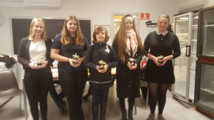

Fra venstre: Anine Parslov Vogelsang – Sara Brix – Valdemar Vibe Utzon – Amalie Engelhart Dall – Amalie Ravn Petersen
Hest – Military
Amalie Ravn Petersen/Cascadeur Rouge – 9 point

Championat 2016 – Vindere
Hest – Military
Sara Brix / Worgaard – 1 point
Hest – spring | Hest – dressur | Pony – spring | Pony – dressur
Christina Andersson /  Palle  24 point | Jacqueline Andersen /  Temptation  44 point | Amalie Dall /  Bøg  86 point | Kristine Hviid /  Coráz Saha  125 point

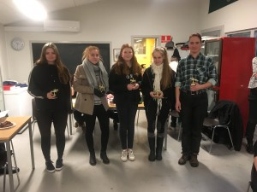
Fra venstre: Sara Brix – Jacqueline Andersen – Kristine Hviid – Amalie Dall – Christina Andersson

Championat 2015 – Vindere

Hest – spring | Hest – dressur | Pony – spring & military | Pony – dressur
Regitze Toft /  Umarla | Camilla Kildegaard /  Futte | Sara Brix /  Lars | Caroline Jelstrup /  Adonis

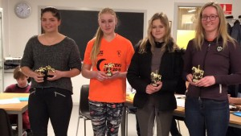
Fra venstre: Sara Brix – Regitze Toft – Caroline Jelstrup – Camilla Kildegaard

Championat 2014 – Vindere

Hest – spring | Hest – dressur | Pony – spring | Pony – dressur
Regitze Toft /  Aisha | Maj Therkildsen /  Call Me | Nina Lillelund Hjorth /  Chester | Caroline Jelstrup /  Adonis

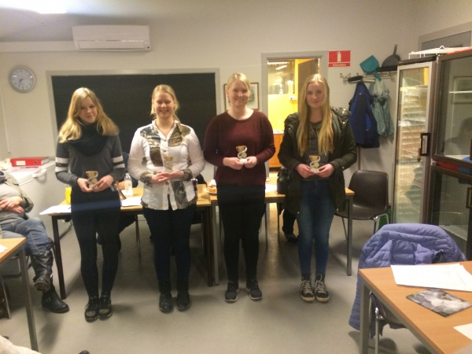
Fra venstre: Caroline Jelstrup /Adonia- Nina Hjorth/Chester – Maj Therkildsen/Call Me – Regitze Toft/Aisha

Championat 2013 – Vindere

Hest – spring | Hest – dressur | Pony – spring | Pony – dressur
Trine Bach/  Rockness | Heidi H. Hansen/  Armani | Regitze Helmer/  Øxenborg’s Pinocchio | Karoline Krog Hansen/  Andbæk’s Shanaya

Championat 2012 – Vindere

Hest – spring | Hest – dressur | Pony – spring | Pony – dressur
Lise Rohden /  Umarla | Camilla Ludvigsen/  Amigo de Nero | Regitze Helmer/  Zoya | Karoline Krog Hansen/  Andbæk’s Shanaya

Rediger
Copyright © 2021 Tuse Næs Køre- og Rideforening. All Rights Reserved. | Catch Responsive af Catch Themes

